Investors Abroad
August 10 · Edited ·
We will be 9 billion by 2050 ...
@Investors Abroad
.
The world population is estimated to grow about 2.4 billion in the next 35 years ... this is about 34% additional inhabitants on the planet ...
What will be the problems and issues the next generation will be confronted with?

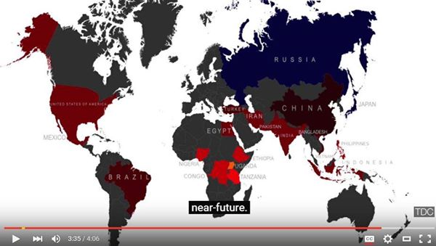

Like Comment Share
- Most Recent
Investors Abroad, Anette Neumann, အရိပ္ ကေလး, Adeel Khan and2 others like this.
- 18 shares
Investors Abroad To watch the video follow this link:
https://www.youtube.com/watch?v=YJjz7LVVl8c

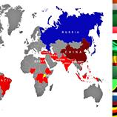

Top 20 Countries by Future Population (2050)
YOUTUBE.COM
Unlike · Reply · Remove Preview · 1 · August 10 at 7:29pm

