Investors Abroad
August 28 at 1:32pm · Edited ·
LIKE our page to receive our posts.
.
Be welcome to post in our page on these topics:
- Traveling and Living Abroad. Residency Abroad
- Immigration, Dual Citizenship, Second Passport...
See More
Investors Abroad
Consulting/Business Services · 11,716 Likes

Like Comment Share
- Most Recent
Investors Abroad, Anette Neumann, Felipe Castro Melo, Aicha Ange and277 others like this.
- 15 shares
- View 4 more comments

Investors Abroad shared their photo.
August 19 at 2:16am ·
Countries compared and their scores for the purpose of retiring abroad:

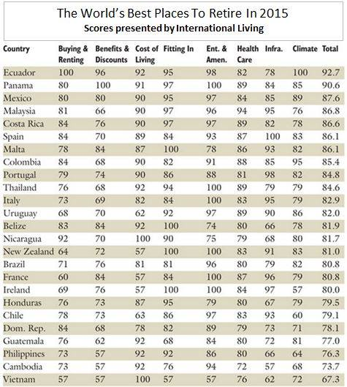

Investors Abroad
Best Places to Retire
@Investors Abroad
.
#‎retire‬‬‬ #‎retirement‬‬‬ #‎pension‬‬‬ #‎retireabroad‬‬‬ #‎financenews‬‬‬ #‎residencyabroad‬‬‬ #‎liveabroad‬‬‬#‎livingabroad‬‬‬ #‎lifeabroad‬‬‬ #‎investorslivingabroad‬‬‬

Like Comment Share
- Most Recent
Investors Abroad, Anette Neumann, Charito Francisco, Felipe Castro Melo and 175 others like this.
- 3 shares
- View 1 more comment
Investors Abroad This page is full of interesting information. Check it: ... ... ...https://www.facebook.com/International.Living
International Living
Travel/Leisure

