OECD economic growth forecasts:
@Investors Abroad
Stable growth momentum in the OECD is anticipated by the Composite Leading Indicators (OECD-CLI), August 2015.
Increased economic growth is expected in the Euro area, especially France and Italy... Chinese economy expected to slow down....
See More

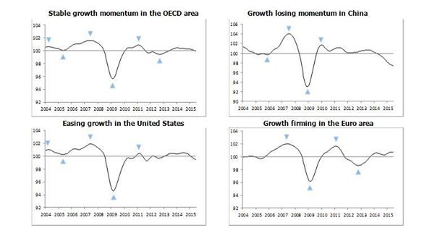

OECD
Indicators point to firming growth in Euro area, especially France & Italy, and slowing in China http://bit.ly/1gWMxpR

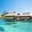
Like Comment Share
- Investors Abroad, Anette Neumann, Tariq Hameed, Stephen Ritter and 49 others like this.
Investors Abroad Read more information here: ... ...http://www.oecd.org/.../composite-leading-indicators-cli...

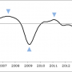

Composite Leading Indicators (CLI), OECD, August 2015
OECD.ORG
Unlike · Reply · Remove Preview · 3 · August 13 at 8:06pm

tors Abroad
Consulting/Business Services · 11,716 Likes

- Traveling and Living Abroad. Residency Abroad
- Immigration, Dual Citizenship, Second Passport...

Travel/Leisure

