Investors Abroad
August 14 · Edited ·
Living Abroad - Wage and tax comparison in the most important countries - compiled by movehub .com
@Investors Abroad
...
#‎wages‬‬‬ #‎taxes‬‬‬ #‎wagecomparison‬‬‬ #‎taxcomparison‬‬‬ #‎livingabroad‬‬‬#‎lifeabroad‬‬‬ #‎residencyabroad‬‬‬ #‎investorsabroad‬‬‬ #‎investmentabroad‬‬‬#‎citizenship‬‬‬ #‎immigration‬‬‬ #‎travel‬‬‬ #‎travelabroad‬‬‬ #‎immigation‬‬‬#‎dualcitizenship‬‬‬ #‎businessimmigration‬‬‬ #‎secondpassport‬‬‬ #‎investproperty‬‬‬#‎investment‬‬‬

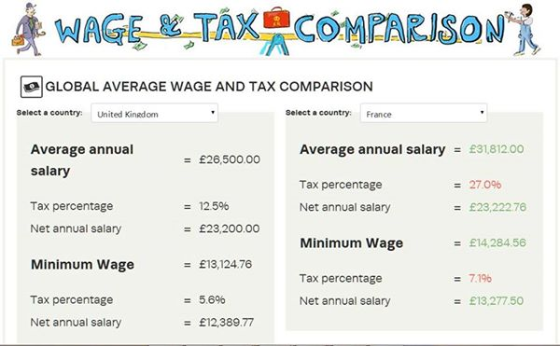

Like Comment Share
- Most Recent
Investors Abroad, Charito Francisco, Anette Neumann, Tariq Hameedand 56 others like this.
- 30 shares
- View 5 more comments
Investors Abroad Comparative cost of living in the USA ... ... ...https://www.facebook.com/taxfoundation/photos/a.141113818864.103390.19219803864/10152370187868865/?type=1

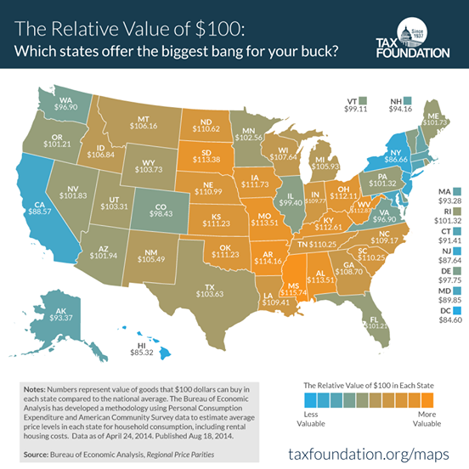

Tax Foundation
New Map: The Relative Value of $100: Which states offer the biggest bang for your buck? http://buff.ly/YpQR7r
Unlike · Reply · Remove Preview · 1 · August 18 at 6:10pm

Investors Abroad
August 28 at 1:32pm · Edited ·
LIKE our page to receive our posts.
.
Be welcome to post in our page on these topics:
- Traveling and Living Abroad. Residency Abroad
- Immigration, Dual Citizenship, Second Passport...
See More
Investors Abroad
Consulting/Business Services · 11,716 Likes

Travel/Leisure

