Investors Abroad added a new photo to the album: Living Abroad - Videos - Dubai.
August 13 ·
The big flight ... Jumping from the Burj Khalifa
@Investors Abroad
#‎BurjKhalifa‬‬‬ #‎Dubai‬‬‬ #‎DubaiVideos‬‬‬ #‎WonderfulDubai‬‬‬

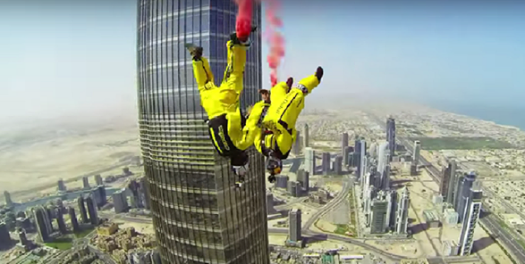

Like Comment Share
- Most Recent
Investors Abroad, Charito Francisco, Anette Neumann, အရိပ္ ကေလး and55 others like this.
- 21 shares
- View 2 more comments
Investors Abroad and here too ... ... ... ...https://www.facebook.com/visitdubai.IN/videos/478853885601511/
Like · Reply · 1 · August 15 at 7:44pm · Edited

Investors Abroad
Business Services · 11,716 Likes

- Traveling and Living Abroad. Residency Abroad
- Immigration, Dual Citizenship, Second Passport...

Travel/Leisure

