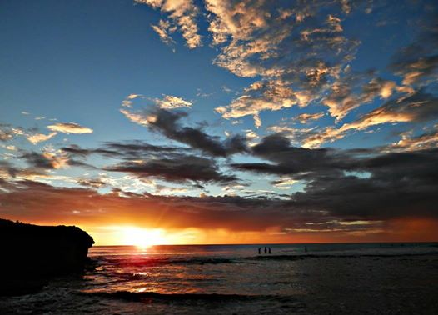

Like · Reply · Remove Preview · August 19 at 2:32am

Investors Abroad shared their photo.
August 18 at 5:30pm ·
Cost of living in the world
@Investors Abroad
.

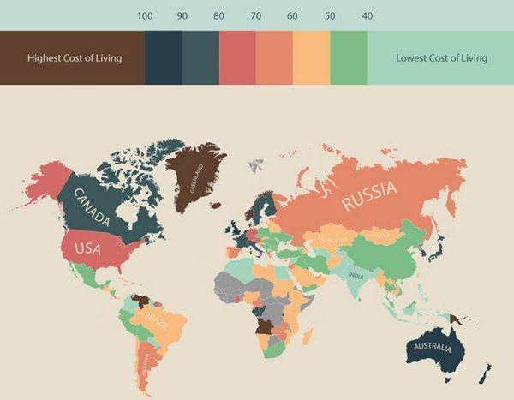

Investors Abroad
Living Abroad - Cost of living in countries and geographic areas
@Investors Abroad
#‎livingabroad‬‬‬ #‎livingcost‬‬‬ #‎costofliving‬‬‬ #‎travel‬‬‬ #‎travelabroad‬‬‬ #‎world‬‬‬

Like Comment Share
- Most Recent
Investors Abroad, Anette Neumann, Charito Francisco, Aicha Ange and175 others like this.
- 25 shares
Investors Abroad Check data and information here: ... ...http://www.movehub.com/blog/living-costs-world-map

Map Shows Cost of Living Around the World
MOVEHUB.COM
Unlike · Reply · Remove Preview · 3 · August 18 at 5:30pm

Investors Abroad
August 28 at 1:32pm · Edited ·
LIKE our page to receive our posts.
.
Be welcome to post in our page on these topics:
- Traveling and Living Abroad. Residency Abroad
- Immigration, Dual Citizenship, Second Passport...
See More
Investors Abroad
Consulting/Business Services · 11,716 Likes

Travel/Leisure

